Breeze Installation on Apple OS

Download the Breeze.dmg from this link https://drive.google.com/drive/folders/1D2T__XT4VHe3WKWwPMqT9Th75rNlkgm2?usp=sharing to your Downloads folder

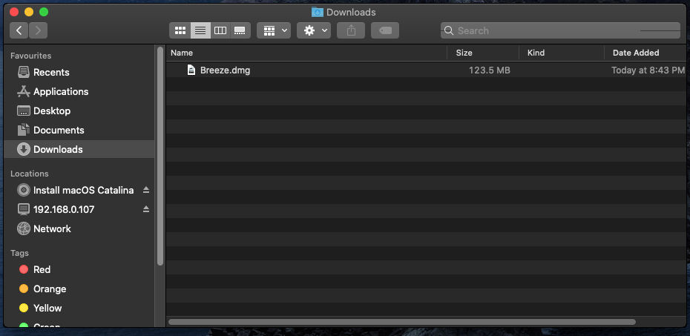
- Double click on Breeze.dmg.
- You will see a disk image on your desktop and you will get to see below window with BreezeBin folder in it.

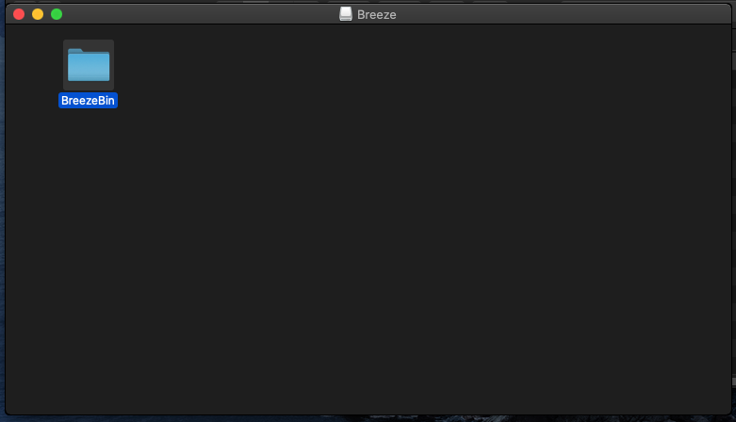
- Copy BreezeBin folder to Downloads folder
- Double click this BreezeBin folder in Downloads folder

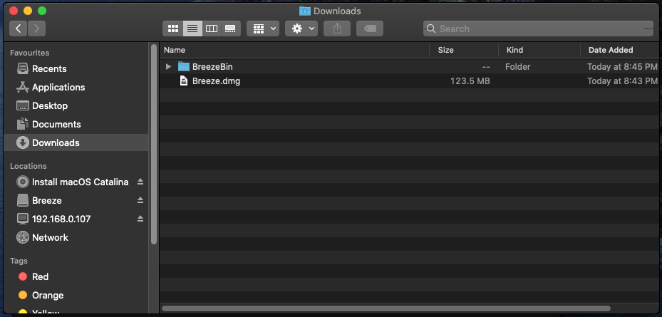
- Double click BreezeSetup to copy the required files and folders to your respective <Home> folder.
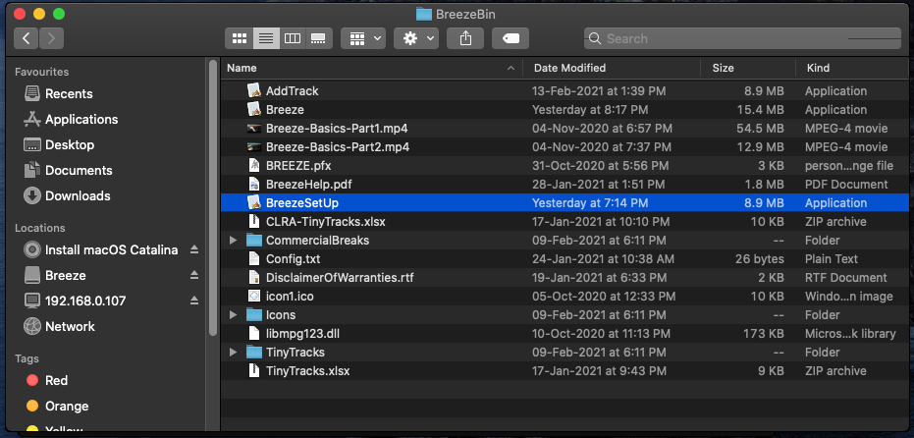

- On the dialog box click the install button
- On completion close this dialog box

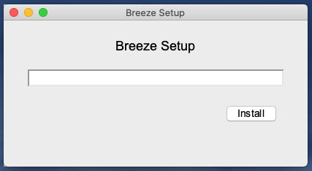

- Click “OK” button to allow access in your Downloads folder
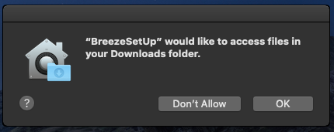

- Close this dialog on completion after installation is complete.

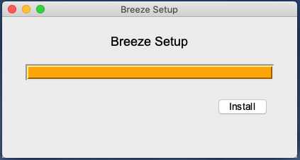

- On the Apple Menu click on Go and select “Home”
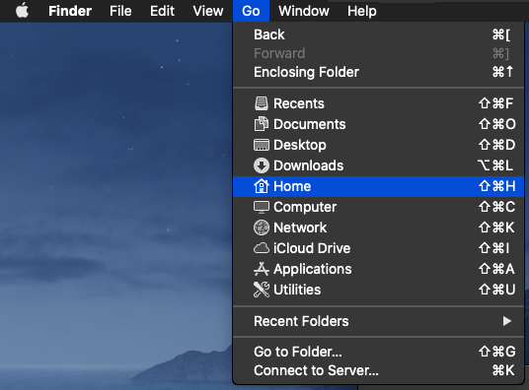

- Then select and double click Breeze folder.

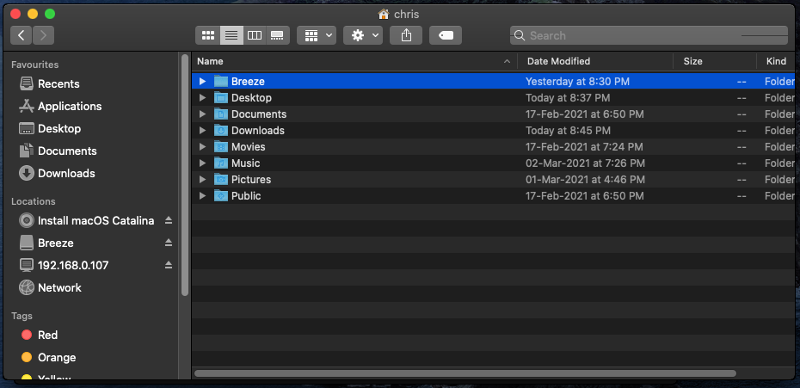

- Double click on the Breeze Application in your <Home>\Breeze folder.

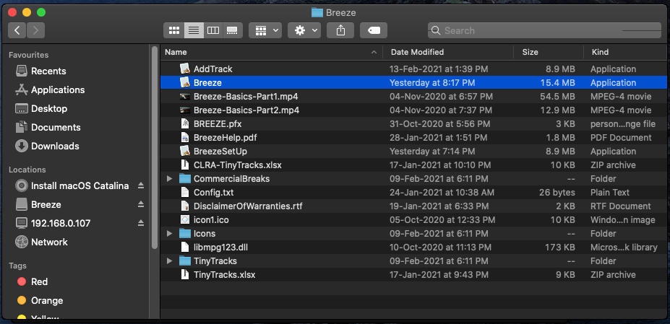

- Breeze Application opens with default Theme

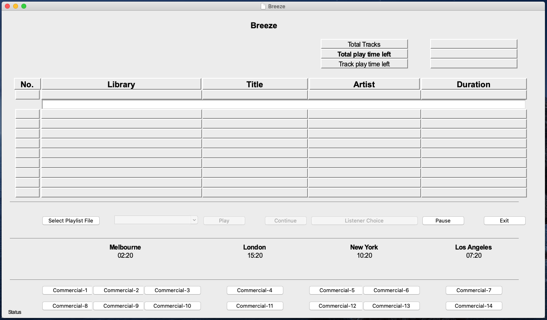

- Breeze App Installation is complete

